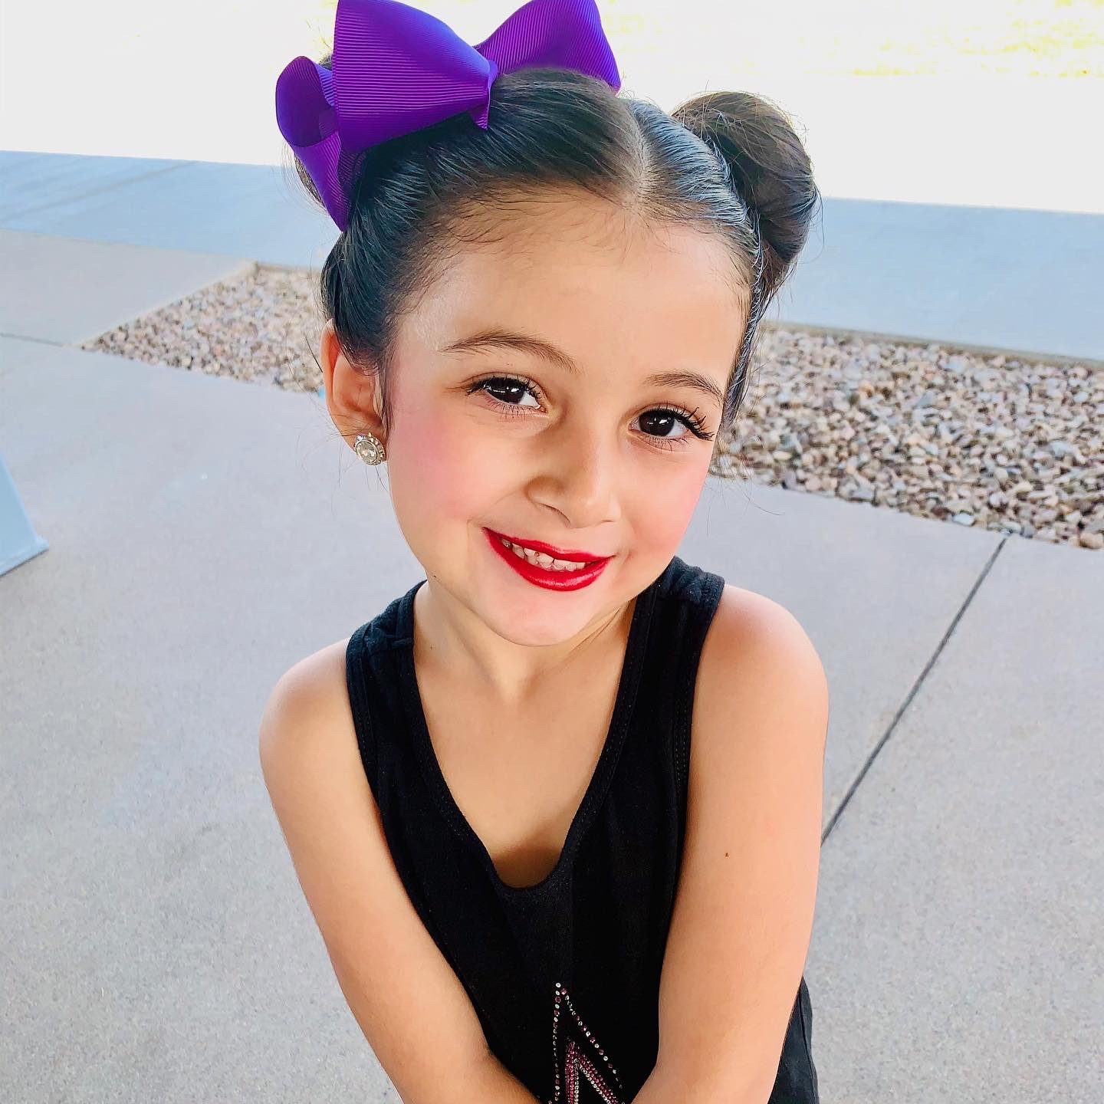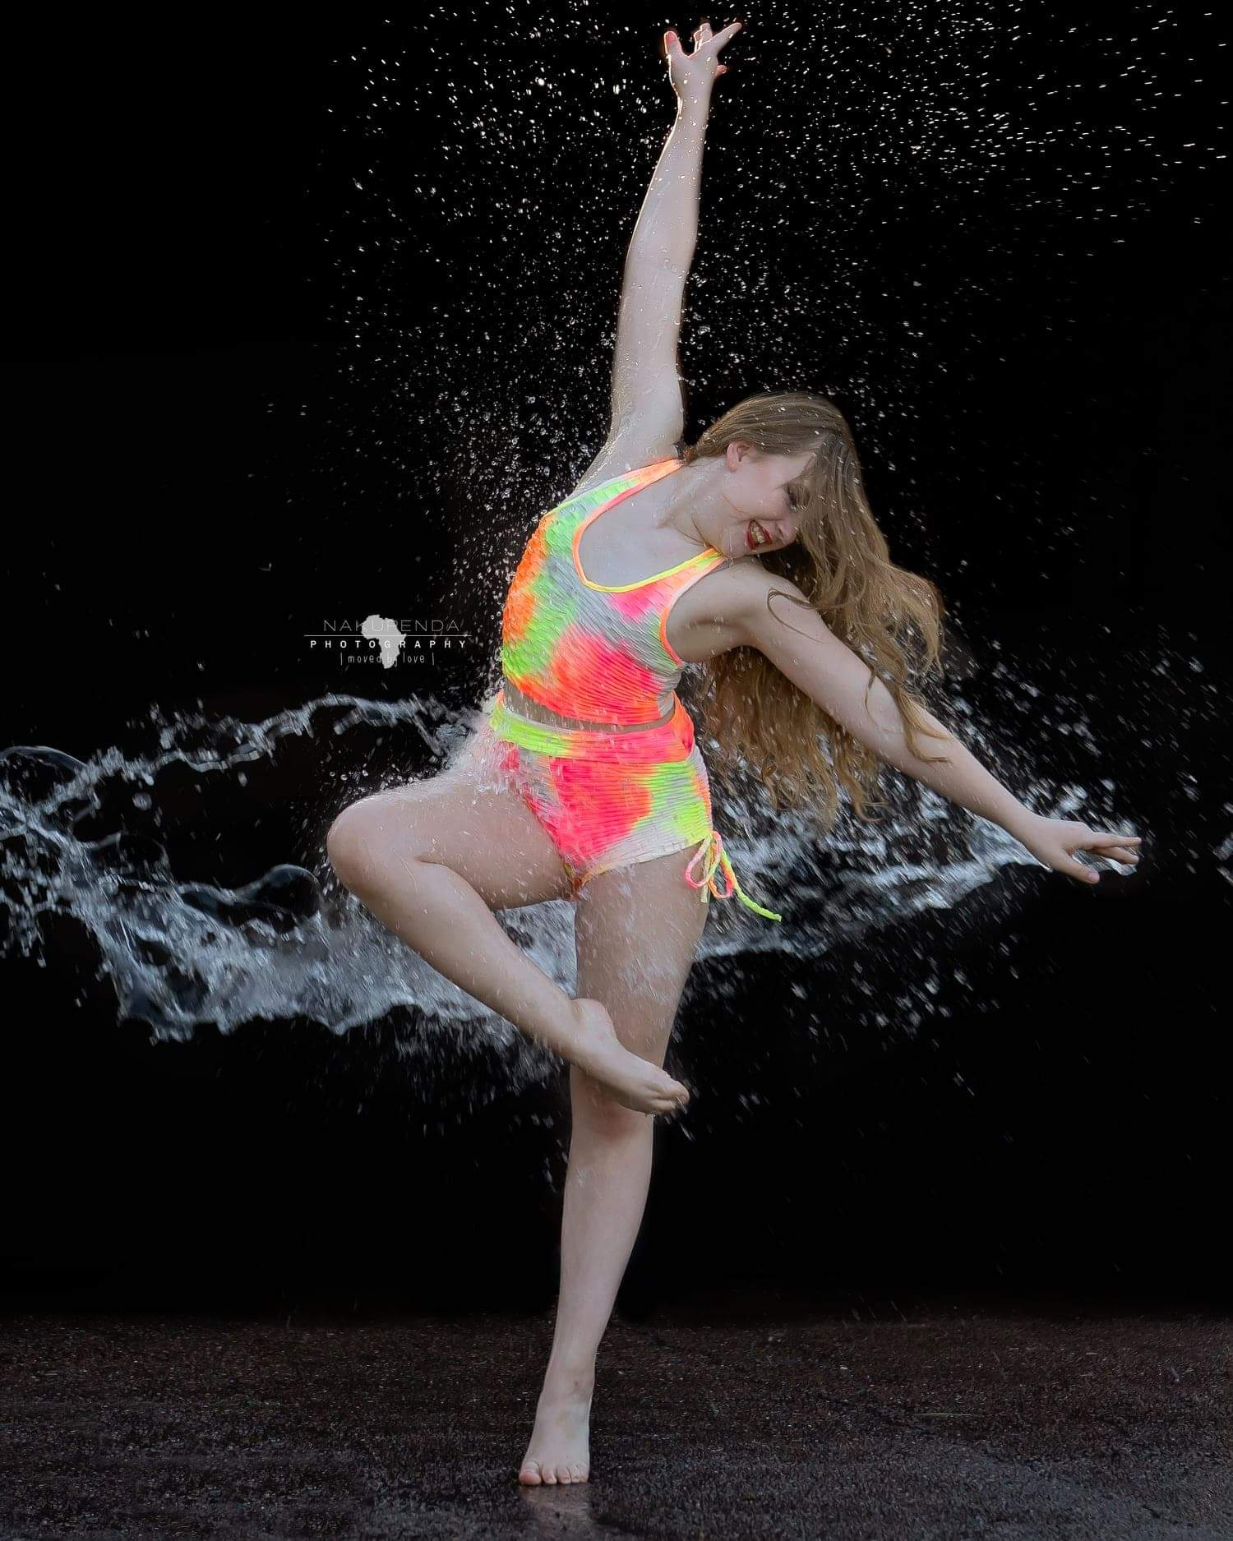

**Summer Dance at JUST DANCE!**

### Week 1

### June 20th- June 24th

### Encanto Camp

### Ages 4-7

### 9am-12pm

### Tik Tok Camp

### Ages 8 Up

### 1pm-4pm

### $130

### Week 2

### July 11th-July 15th

### Ages 4-7

### Princess Party

### 9AM-12PM

### Ages 8 up

### Brooadway Camp

### 1-4pm

### $130

### Beginning June 14th

### TAP BALLET TUMBLE CLASSES

### Ages 2-5

### Tuesdays 6:30pm

### Fridays 4:30pm

### Saturdays 9:30am

### Saturdays 11:30am

### $55 per month

Jazz, Ballet, Musical Theatre and Technique Classes

July 11th-Aug 3rd

**Themed dancing and activities, Crafts, Technique and Training. Jazz, Tap, Ballet, , Musical Theatre, , Turns, Leaps Conditioning Classes and MORE!**

CALL 480-634-1239

# ***Get out of the hot sun and into the dance studio to have FUN and advance your dance training!***

Just Dance!

2976 N Alma School Rd

Chandler AZ

480-634-1239

[Info@JustDanceAZ.com](mailto:Info@JustDanceAZ.com)

www.JustDanceAZ.com

#### **.JustDanceAZ.com**